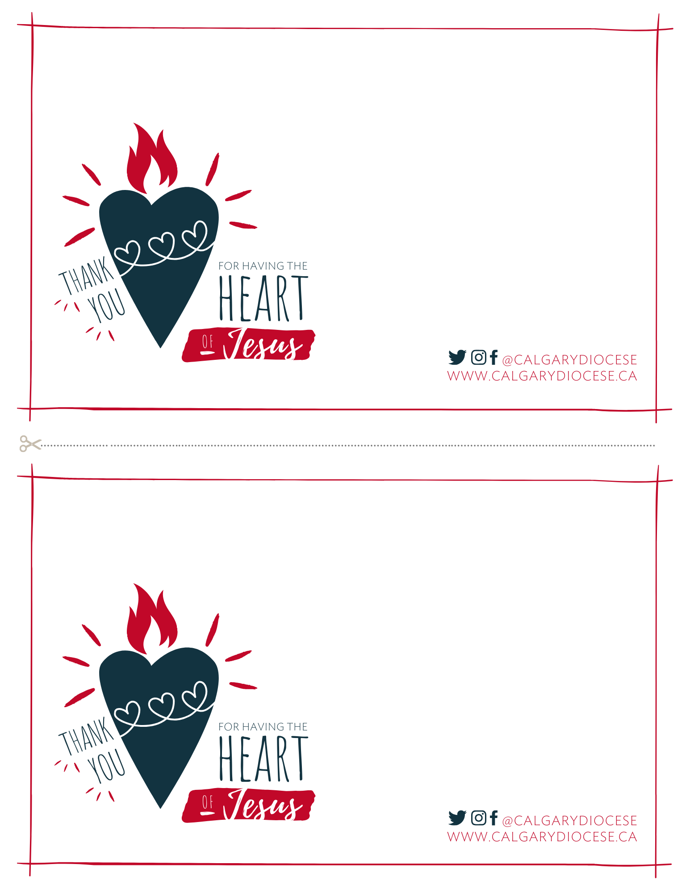

[Text goes here]

[Text goes here]