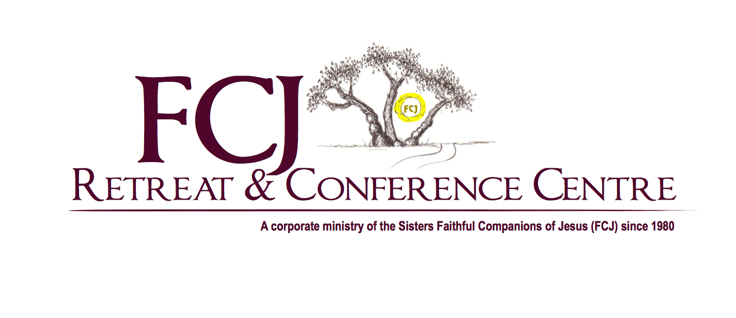
POSITION TITLE: Communication, Marketing, and Fund Development Specialist
DEPARTMENT: Administrative
REPORTS TO: Executive Director

Overall Responsibilities:
Versatile, creative and committed to excellence, the Communications, Marketing and Fund Development Specialist is responsible for the development and implementation of an integrated communications and marketing plan that promotes the FCJ Retreat and Conference Centre and supports the overall strategic vision and fund development revenue goals of the organization.

This role is also responsible for the growth and maintenance of fundraising revenues. Financial and in-kind support will be achieved through building relationships and securing support with current individual and corporate donors and sponsors as well as new prospective supporters.

Major Responsibilities:
Communications and Outreach
- Develops an integrated strategic communications and media relations plan to build public awareness and a positive perception of the FCJ Retreat and Conference Centre.
- Employs outreach strategies on and offline and a variety of public relations and marketing tactics to engage existing stakeholders and attract new donors, volunteers and supporters to the organization.
- Maintains an active voice in social media on Facebook, Twitter and other media that are relevant to key communications of families and supporters
- Maintains the FCJ Christian Life Centre Website.
- Uploads to our website and supports online registration of the various programs and events offered by the Centre.
- Writes, prepares and supports the development of e-newsletters, annual report, news releases, and electronic media
- Researches and prepares grant proposals.
- Regular monitoring, analysis, evaluation and reporting on media relations activity
- Key point of contact to donors, volunteers and local communities Fundraising and Donor Stewardship
- Plans, implements and manages all aspects of fundraising programs and special events as well as subsequent communications with both internal and external key stakeholders
- Responsible for development of the annual Fundraising Plan
- Recommends and implements appropriate fundraising strategies for current and new corporate and individual donors, Planned Giving and sponsorships
- Cultivates donor relations and stewardship
- Analyzes trends and provides recommendations and strategies for future growth
- Monitors, re-evaluates and adjusts the delivery of plans as necessary
- Key point of contact for all inquiries from donors, sponsors, event participants.
- Works closely with the Director, Finance, Business Operations and volunteer coordinator.
- Operates within the philosophy, culture and core values of the organization.

Qualifications:
- University Degree and/or a College Diploma in Fundraising Management, Communications or Marketing
- 2 to 5 years experience in communications and fundraising/events management
- Strong written and oral communication skills
- Proficient computer skills in MS Office applications
- Advanced knowledge in Adobe Creative Cloud (InDesign and Photoshop), WordPress and Donor Recognition Software as well as WIX and Salesforce
- Demonstrated technical experience in the realm of social media
- Strong interpersonal, customer service, problem solving and planning skills are required
- Organizational ability and attention to detail
- Self-starter, capable of identifying the need for taking independent action and demonstrated ability to work both in a team environment
- Access to a vehicle is required for travel
- Required to work flexible hours, including some evenings and weekends and work a flexed workday as will be required to attend events and functions or in preparation for same

Qualified candidates are invited to submit a cover letter and resume no later than August 10, 2021 to:
Denise DeNeve denise.deneve@fcjcentre.ca
We thank you in advance for your interest. Only those candidates with the minimum qualifications will be contacted and considered for an interview.

