Diocesan Youth Retreat Team
FIRST EUCHARIST
RESOURCES BOOKLET
March 2019

TABLE OF CONTENTS
Icebreakers & Games 1
Two Truths and a Lie 1
Pull Ups 1
Bread Basket 2
Church Tour Guide 3
Places in the Church 3
Objects in the Church 3
Sacred Vessels & Objects 4
Liturgical Books 4
Priest's Vestments 5
Liturgical Colors 6
Skits & Melodramas 7
We Come to Celebrate Skit 7
Passover Melodrama 9
Additional Resources 13
Sacrifice 13
The Real Presence 13
Ball Demonstration 14
Feeding of the Five Thousand 15

ICEBREAKERS & GAMES

TWO TRUTHS AND A LIE

Have each person share 3 facts about themselves, 1 of which is not true. Everyone else must decide which of the facts is not true.

If working with a larger group, you can have everyone break up into smaller groups and share their facts with each other.

PULL UPS

Objective
To include everyone in a fun game that mixes people up while at the same time creating a friendly boys versus girls competition.

Materials
- a music source (i.e. laptop, phone, speakers, etc.)
- music playlist

Instructions
- Have everyone sit down on the ground in a circle. Ask for an even number of boy volunteers and girl volunteers to stand in the middle of the circle.
- When the music starts playing, the boys and girls in the middle must each go up to a person of the opposite gender (make sure that they find someone across the circle, not someone directly beside them), gently grab his/her hand, and pull him/her into a standing position, then sit down in his/her place. You are not allowed to refuse someone when they grab your hand.
- Explain that for each round, there will be a different theme that the people in the middle have to act out. For example, one round might be a jungle-themed song where they have to act like jungle animals. In another round, you might have the Star Wars theme song playing and they act like jedis, etc.
- After a short time, stop the music and count the number of boys and girls in the middle. The team that has the least number of people wins that round. Play several rounds before declaring a winner. Start each new round with the people who were standing in the middle when the last round ended.
- Inform the group that this is a friendly competition between boys and girls, and the point is to make sure that there are more people from the opposite gender in the middle of the circle when the music stops.

BREAD BASKET

Instructions:
Give each child an ingredient for making bread

  - Flour (people as individual grains of flour forming a community)
  - Yeast (to help us grow together as community)
  - Water (to help bind us all together)
  - Salt (to keep us thirsty for God)
  - Sugar (to remind us of God’s sweet love for us)

Have all the children sit (or stand) in a circle, with one volunteer in the middle. Explain that the person in the middle can call out any combination of the ingredients to make bread (i.e. Flour and Water), and those who have been assigned this ingredient must run to the other side and find a new place.

Emphasize that they cannot just move over to the spot next to them, but they have to go across the circle. Whoever is the last person to find a new spot is now in the middle.

If “Bread Basket” is called out, then EVERYONE has to find a new place!

Alternative: Have a catechist tell a story about baking bread using the words above (flour, yeast, water, salt, sugar) instead of having the person in the middle of the circle call out words.

Tip: To help keep track of spots, have everyone remove one of their shoes. When a word is called, everyone has to find a new shoe (they are not allowed to go to their own shoe).

Discussion:
- Ask the participants what they think would happen if one of these ingredients that is needed to make bread was forgotten or left out (recipe wouldn’t work, it would be a big mess)
- Explain that just as we all have different ingredients, we are all individuals
- However, just like when we mix our bread ingredients to make bread, when we come together and put our gifts to use we all make up the Body of Christ

CHURCH TOUR GUIDE

Note: Please do not feel the need to cover everything included in this guide. Feel free to make modifications to fit your particular needs. Due to time constraints, we suggest focusing mainly on the "Objects in the Church" and "Sacred Vessels & Objects"

PLACES IN THE CHURCH

- Narthex - The gathering area of the church; it is the area between the main doors and the main body of the church.
- Nave - The main body of the church, where the congregation gathers to worship and the pews are located.
- Sacristy - The room where sacred vessels and vestments are kept and where the Priest, Deacon, Altar Servers, and other Liturgical Ministers prepare for Mass.
- Sanctuary - The area around the altar; the altar, ambo, presider's chair, and credence table are located in this area.

OBJECTS IN THE CHURCH

- Baptismal Font - A basin or pool of water used for the Sacrament of Baptism. The baptismal font can be found near the entrance, near the sacristy, or sometimes in a different room or building (called a baptistery).
- Holy Water Font - A vessel filled with Holy Water, located near doors or the entrance to the main body of the church. The faithful dip their fingers in the Holy Water and bless themselves with the Sign of the Cross as a remembrance of Baptism.
- Paschal (Easter) Candle - The large white candle next to the baptismal font. Every year, a new Paschal Candle is blessed and lit from the Easter fire during the Easter Vigil. The candle has the first and last letters of the Greek alphabet (Alpha and Omega), symbolizing Christ as the beginning and end. It also has five grains of incense, representing Christ's wounds. The Paschal Candle is lit during the season of Easter, at baptisms, and at funerals.
- Ambry - Where the Sacred Oils (the Oil of the Sick, the Oil of Catechumens, and Chrism Oil) are displayed. These oils are used for Baptism, Confirmation, Priestly Ordinations, and Anointing of the Sick.
- Offertory Table - A small table near the back of the church used to place the wine and hosts before Mass. During the Presentation of the Gifts, the wine and hosts are carried to the front of the church.
- Pews - The long benches that fill the nave, where the congregation sits. Some churches may have chairs instead of pews.
- Tabernacle - The solid case where the Blessed Sacrament is kept. When passing the Tabernacle, it is a sign of reverence to genuflect. (Demonstrate how to genuflect)
- Sanctuary Lamp - The red candle or lamp close to the Tabernacle, indicating that the Blessed Sacrament is present.
- Crucifix - A cross with Christ's body affixed to it. The crucifix is located in a visible area, such as behind or above the altar. The crucifix is a reminder of Christ's Passion, Death, and Resurrection.
- Processional Cross and Candles - The crucifix attached to a pole and candles carried by the Cross and Candle Bearers during the procession and recessional.
- Ambo - The stand from which the Sacred Scriptures are proclaimed during Mass.
- Presider's Chair - The chair that the celebrant (whoever is celebrating Mass: Priest or Bishop) sits on during Mass. The chair symbolizes the importance of a priest's role as the leader of the community.
- Altar - The table on which the Holy Sacrifice of the Mass takes place. It is where the bread and wine are consecrated into the Body and Blood of Christ.
- Altar Bells - The bells rung after the consecration of both the bread and wine.
- Credence Table - The small table near the altar where the sacred vessels and other liturgical objects are placed when not in use during the Mass.

SACRED VESSELS & OBJECTS

- Chalice - The cup used to hold the wine that will be consecrated into the Blood of Christ.
- Paten - A round plate or shallow dish used to hold the large host that will be consecrated into the Body of Christ.
- Ciborium - The vessel used to hold hosts to be used for communion. A covered ciborium is used to reserve consecrated hosts in the Tabernacle.
- Corporal - The white linen cloth on which the vessels containing the bread and wine are placed on at the altar.
- Pall - A stiff, white square used to cover the chalice (or paten when it is on the chalice).
- Purificator - The white linen cloth used to cleanse the chalice after communion. It is also used to wipe the edge of the chalice after each person receives the Precious Blood.
- Cruets - The small vessels (usually made from glass) that hold the water and wine.
- Lavabo Bowl & Towel - Used by the priest to wash and dry his hands before the consecration.

LITURGICAL BOOKS

- Sacramentary - Contains all of the prayers, blessings, and rituals said by the Priest and Deacon during Mass.
- Book of the Gospels - Contains the Gospel readings for each Sunday, as well as for other Masses celebrated throughout the year. It is carried during the procession.
- Lectionary - Contains the Scripture Readings for Mass. It is not carried during the procession and should be placed at the ambo before Mass.
- Hymnal/Missalette - Contains all the Mass parts for the congregation, as well as instructions on when to sit, stand, or kneel.

PRIEST'S VESTMENTS

Note: You may want to ask a priest or deacon to explain the vestments to the participants. If the participants see how a priest wears the vestments, it may help them better understand.

- Amice - A white cloth worn over the neck and shoulders.
- Alb - A long white robe with sleeves worn by the priest during Mass. The white colour of the alb symbolizes purity.
- Cincture - A long, rope-like cord tied around the waist over the alb. The cincture symbolizes chastity and purity.
- Stole - A long piece of cloth that looks like a scarf. It is worn around the neck with the two ends hanging at the front.
- Chasuble - A poncho-like outer garment worn over all other vestments. Different colours are worn depending on the liturgical feast or season.
- Cassock - An ankle-length garment, usually black in color.

Additional Resource
Images from https://catholic-link.org/images/gallery-significance-priests-vestments/

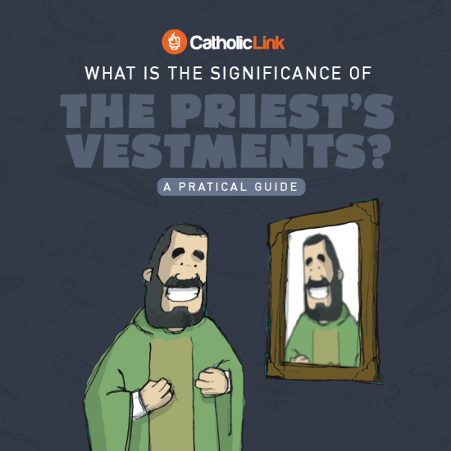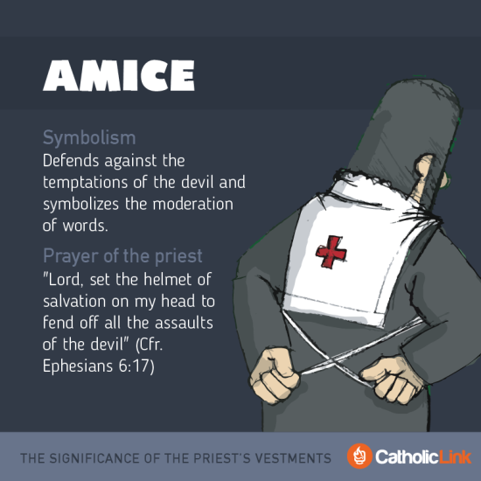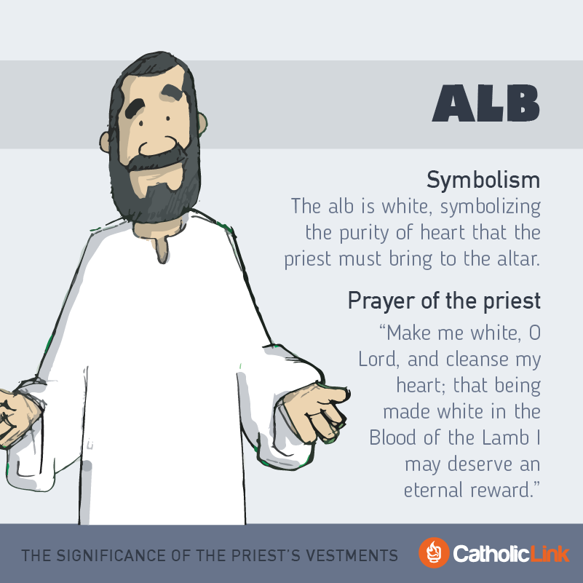

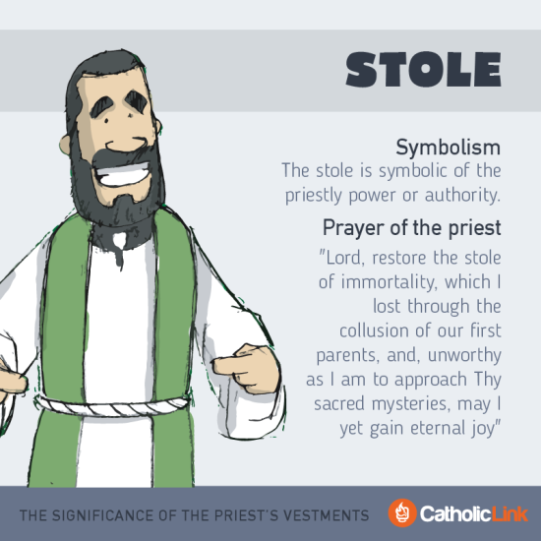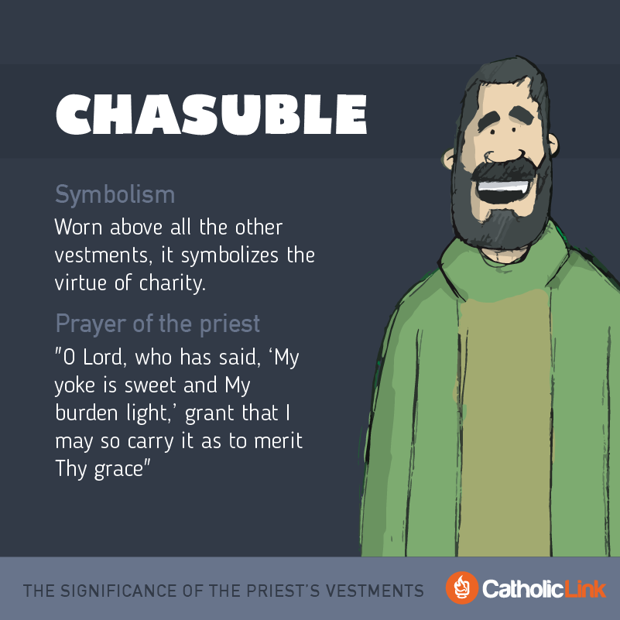
LITURGICAL COLORS
(Taken from page 84 of the Celebrate and Remember: Eucharist Catechist Guide)

Every liturgical season has its own color. The colors of the vestments, altar cloths, and other accessories for worship help us immerse ourselves in each season. The seasons with their colors are:

- Advent: violet
- Christmas: white
- Ordinary Time: green
- Lent: violet/purple

Additional Resource
Image from https://catholic-link.org/images/infographic-significance-liturgical-colors/

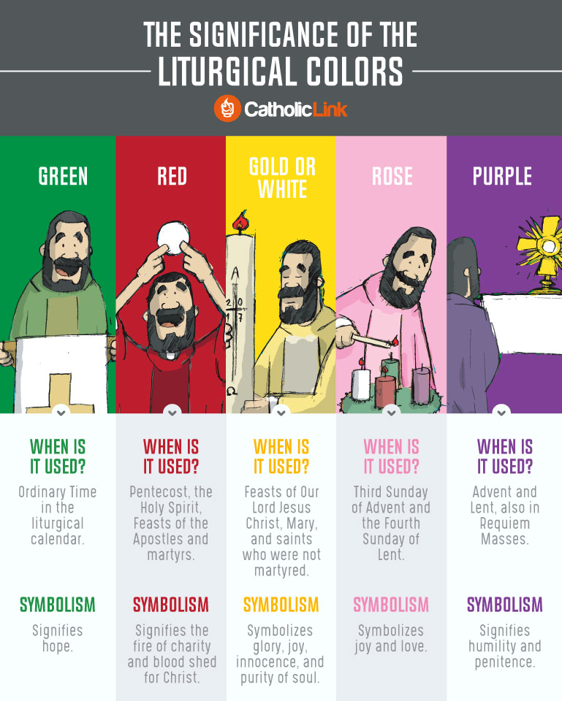

Additional Resources
- https://www.youtube.com/watch?v=ZfR2Rk7e198
- http://www.bemydisciples.com/tour-church
- https://slideplayer.com/slide/7518812/
SKITS & MELDRAMAS

WE COME TO CELEBRATE SKIT

Objective: To demonstrate that Mass, besides being a sacrament, is a celebration, an invitation to a party hosted by Jesus.

Cast
- parent (well dressed for a fancy party)
- child (well dressed for a fancy party)
Props
- two chairs (side-by-side)
- gift box or bag

Parent: (knocks on door of child’s room) Child, are you ready to go?

Child: I’m ready! (comes out of the room)

Parent: Wow, you look great! You picked out your best clothes.

Child: Of course! We are going to a really special celebration.

Parent: Ok, let’s get in the car.

(all take a seat on chairs; parent mimics holding a steering wheel and driving)

Parent: You brought a nice gift to the banquet.

Child: Yes, it’s what our celebrant would really like.

Parent: Are you excited?

Child: I don’t know what to expect. I’m kind of nervous.

Parent: Don’t worry. It will be a joyous celebration. We’ll tell stories, give gifts and share a meal.

Child: Ok, I’m excited again!

Parent: Good, we have arrived.

(show a picture of a Church on the screen)

Discussion Questions
- Ask the students what we celebrate?
  - Birthdays, anniversaries, holidays, etc.
- Ask why we celebrate these events?
  - We celebrate these events in order to remember the important things that happen in our life
- So why do we celebrate Mass?
  - It is to remember the last supper of Jesus and His disciples, His death and His resurrection
  - During the Mass, we share a meal together, not just with our family, but with the whole family of the Church
  - We remember that through Jesus’ love for us, He died to save us from all our sins
  - We also remember because Jesus is still alive and with us in our hearts, so we continue to remember that He is present
- Celebrating Mass is like going to a big banquet. We share stories (the readings), we give gifts (offertory) and we share a meal (Eucharist). When we remember these things, it’s like going to a party every Sunday! How could Mass be boring?

PASSOVER MELODRAMA

The night before Jesus died,
(stretch out arms to form a cross)

he ate a Passover meal with his friends.
(make eating motions with hands)

All Jews celebrate this feast
(sweep arms widely to emphasize “all”)

to remember how the angel of death
(flap arms for angel’s wings)

PASSED OVER their houses in Egypt,
(sweep arms in high arch on “passed over”)

which they marked with blood from a lamb.
(mark an “X” on an imaginary doorpost)

Also, they remember
(tap temple)

how Moses and the Jews PASSED OVER the Sea of Reeds
(sweep arms in high arch on “passed over”)

with dry feet
(point to feet with a surprised look)

when they escaped from Egypt.
(run in place)

It all happened so fast
(snap fingers quickly several times)

their bread didn’t have time to rise!
(tap wristwatch)

That’s why Jews ate unleavened bread at Passover.
(place on palm on other, flat as a pancake)

Passover has long been a very special feast.
(Nod head with certainty)

Jesus was happy to share it with his friends.
(turn up corners of mouth with index fingers to make a happy face)

When they were still eating,
(make eating motions)

Jesus took the BREAD in his hands
(pretend to lift up the bread)

He gave his Father thanks and praise,
(point to Heaven)

then he broke the bread
(break bread)

and gave it to his disciples.
(hand “bread” all around)

He said, “Take this, all of you,
(point to several people on the word “you”)

and eat it.
(making eating motions)

This is my Body.”
(point to your own body)

The disciples didn’t know what he meant.
(scratch and shake head)

But they remembered it later.
(tap temple and nod)

When the supper was ended,
(make eating motions)

Jesus took the CUP,
(pretend to lift the cup)

and gave his Father thanks and praise.
(point to Heaven)

He said, “Take this, all of you
(point to several people on the word “you”)

and drink from it.
(making drinking motions)

This is the cup of my Blood.”
(point to your own body)

The disciples didn’t know what Jesus meant.
(scratch and shake head)

But they remembered it later.
(tap temple and nod)

Then Jesus stood up,
(rise from a crouching position)

and tied a towel around his waist.
(wrap imaginary towel like an apron around your waist)

He poured water in a bowl
(make pouring motions)

and began washing his disciples’ feet.
(point to several children’s feet)

Peter said, “Stop, Lord!”
(make a “time out” sign with your hands)

“YOU can’t wash MY feet!”
(point to “you” and then to your own feet)

Jesus said, “You don’t understand now,
(shake your head)

But later you will.
(nod your head)

If I don’t wash your feet,
(point to feet)

you won’t be my disciples anymore.
(tap your chest on the word “my”)

Peter said, “Then, YES, Lord!
(nod head vigorously)

Wash my feet AND my hands AND my head!”
(point excitedly to feet and hands and head)

Then Jesus washed all their feet.
(point to everyone’s feet)

He said, “Do you understand what I just did?
(point to yourself)

I set an example for you.
(point to several others on the word “you”)

You should wash one another’s feet.”
(point to everyone’s feet)

The disciples STILL didn’t quite understand.
(scratch and shake head)

But they remembered it later.
(tap temple)

And we remember it too,
(gesture to all, sweeping arm inclusively)

every time we go to Mass
(walk in place)

and every time we receive Communion.
(hold up nested hands to receive Communion)

We remember that Jesus gave us his body and blood,
(fold hands and bow head in thanks)

that Jesus is our NEW PASSOVER,
(sweep arm high in arch on word “Passover”)

and that Jesus taught us to wash each other’s feet.
(point to everybody’s feet)

We might not quite understand it,
(shake head and scratch it)

but we remember Jesus
(tap temple)

and we remember and we believe (say this line twice)
(tap temple, cross hands over heart)

Debrief
- Ask the participants if any of them can explain what the Passover is. (Explain that Passover is a meal that Jews celebrate to remember the Exodus – when God made the Egyptians let the Israelites out of Egypt).
- Ask them how much they can remember about this story.
- Explain that God told the Israelites to sacrifice a lamb and put the blood of the lamb on their doorposts so that God would “pass over” their house when he took the first born of each of the Egyptian families.
- Explain that this is why we call Jesus the Lamb of God – that he is the Final Sacrifice that God gave so our sins would be forgiven.
- This shows how much God loves us, that he gave his only Son for us so that our sins would be forgiven.

ADDITIONAL RESOURCS

SACRIFICE

- Ask the students if they think their parents love them? How do they know that?
  - They feed us, they take care of our needs
- Can you say that they sacrifice for us?
  - They work and instead of using their money for themselves, they buy us toys, new clothes, take us on trips, etc. That’s how they love us.
- Jesus loves us too. He also sacrifices for us. Each time during the Mass, the bread and wine become Jesus’ Body and Blood, so it shows that Jesus is alive and present with us. As Catholics, we believe that during Communion, the bread and wine are not just bread and wine. They are actually the Body and Blood of Jesus. This means that Jesus is alive with us.
- Even if this looks like bread and looks like wine, this is actually Jesus’ Body and Blood. This is the sacrifice that Jesus makes for us every time we go to Mass.

THE REAL PRESENCE

Purpose: The purpose of this session is for the children to think about our Catholic belief that Jesus is present in the Eucharist: Body, Blood, Soul and Divinity. Just because it looks like bread and wine, doesn’t mean that it is just bread and wine

Materials
- a box with something already inside it (i.e. set of keys surrounded in paper so they don't rattle)
- a picture of a Tabernacle (or be close to the Tabernacle)

Instructions
- Hold up a small box in which some keys have been secretly placed, and won’t rattle together.
- Say, "My keys are present in this box. Do you believe that this is true? Why or why not?"
- Put the box down with the mystery unresolved.
- Hold up the picture of the Tabernacle (or direct the attention of the children to the Tabernacle).
- Say, "This is a picture of the Tabernacle (or this is the Tabernacle), and as Catholics we believe that Jesus is alive inside this box. How do we know He is present? How can we share in His presence?

Discussion:
- How do we know that Jesus is present in the Eucharist?
- When the priest prays, “Take this, all of you, and eat of it, for this is my Body which will be given up for you..." and “Take this, all of you, and drink from it, for this it the chalice of my Blood..." he is praying the words of Jesus himself. The bread and wine change into the Body and Blood of Jesus.
- Explain to the children that the Eucharist is a Mystery. But unlike the mysteries that they may read in books or watch in movies, this is not a mystery that can be solved. We can understand parts of it, and the more that we seek to understand, the more that the Holy Spirit will help us to understand.
- But just because we can’t fully understand it doesn’t mean that we can’t trust it. This is where faith comes in.

BALL DEMONSTRATION

Materials
- a rubber ball, big enough to hold in one hand

Instructions
- Pick up a ball in your hand. Ask someone to examine it, so they can tell everyone that it is a regular ball. Ask the group if they believe that if you drop the ball, it will fall to the ground. Ask them if they’re sure. Could they be wrong? What if you told them it was a special ball that didn’t fall to the ground, but would actually float up to the ceiling, would they believe you?
- Say, "We know from EXPERIENCE that if I drop this ball, it will fall to the ground. This is called gravity. Now, could you explain gravity to someone who’s never experienced it? Imagine if someone was born in outer-space, lived in outer-space, and has never set foot on Earth or any other planet. They would have never experienced gravity. They couldn’t know that dropping the ball would cause it to fall to the ground out of experience, but if you told them and they believed you, what is that called? (Faith = Trust)."
- Ask, "So, the question is, do you trust Jesus? Just because the Eucharist doesn’t look like Jesus, doesn’t mean it can’t be Jesus. If you trust him, then you should also be able to trust what he says, that this is truly his Body and his Blood.

FEEDING OF THE FIVE THOUSAND

Pre-Explanation
- Lay a blanket or sheet on the floor, and have the children sit around/on it in a circle.
- Explain that they are to pretend they are going on a picnic. They can each take one item, but that item must begin with the same letter as their name, and no item can be repeated.
- Go around the circle once or twice, depending on time, number of children, and enthusiasm.
- After everyone has named their item(s), ask: “If we brought everything we named to a picnic, would it be enough to feed everyone?”
- Let them know that today they will be learning about a time when Jesus fed people at a big picnic.

Bible Story and Debrief
- Read the story of the Jesus feeding the five thousand from a children’s Bible. Children may act it out along with the story.
- Ask the children about times when they get hungry. Why do we need to eat? What happens if we don’t eat?
- Talk about how the people in the story followed Jesus. The people in the story walked and listened and sat and traveled with Jesus. Why did they get hungry? What would have happened if they didn’t get food?
- What are some ways that we follow Jesus? What are some ways that it is difficult to follow Jesus? Why might we get hungry? How is this different from the way the people in the story were hungry?
- Jesus gives us the gift of the Eucharist to feed us and keep us strong, so we can keep following him.
- What did Jesus do to feed the people in the story? How do you think the disciples and the young boy felt when they realized the miracle that had happened?
- The Eucharist is a similar type of miracle, because all of us, and all Catholics around the whole world, are fed from Jesus’ one body that died on the cross. Jesus feeds his whole church in the Eucharist, so we witness a miracle each time we come to Mass and receive the Eucharist.
- How should we feel and act when we witness this miracle?

