Litany of Saints
Easter Vigil

In this guide you will find:
- Answers to common questions about the Litany of Saints on the Easter Vigil
- A template to help you add saints in the correct position
- A template including music for your cantor to which you can easily add invocations

Common Questions

How Do I Know Whether to Sing the Litany?
- If there are baptisms, you sing the Litany and use the blessing at Roman Missal nos. 44/46
- If the font is to be blessed, but no one is to be baptized you sing the Litany and use the blessing at Roman Missal nos. 44/46
- If no one is to be baptized and the font is not to be blessed, the Litany is omitted and you use the Blessing of Water at Roman Missal no. 54

Which Litany Do I Sing?
The Litany of Saints should follow the Litany printed in Roman Missal no. 43 pp. 351 – 353.

May I Add Saints?
Yes! Names of some saints may be added, (Roman Missal no. 43 on p. 351) especially:
- names of the Titular Saints of the church
- names of the Patron Saints in the place
- patron saint names of those to be baptized

Does the Position of the Saints Matter?
Yes! There are specific rules about where to add saints in the Litany. These will be explained below.

What Is the Method of Singing?
The Litany is to be sung by two cantors (Roman Missal no. 44 on p. 351). This means that the cantors alternate singing the invocations with the rest of the people responding, not that the two cantors sing together. If you do not have two cantors then you would, by necessity, use a single cantor. The nature of the Litany is call and response so you do not want everybody singing everything. The choir is to support the people in the response, not to replace the cantor.

Can We Sing a Different Melody from the Roman Missal?
You may use a different melody if you:
- Retain the form of call and response between cantors and people/choir
- Make sure that the text matches the Roman Missal

How to Add Saints to the Litany

Canadian Saints
The template provided already includes the Canadian Saints along with their dates of death.

Order of Adding Saints
Saints are added to the Litany in the following order:
- By rank
- Men before women (customarily)
- Date of death (heavenly birthday)
The template gives you the Saints from the Litany in the Roman Missal grouped in order by rank with the addition of the Canadian Saints. To add a saint do the following:
- For each saint you wish to add, determine their rank, whether the saint is male or female, and the saint’s date of death
- Find the rank on the template and type the saint’s name into the proper position. It is helpful to include the date of death on this list. You may have to look up the date of death of other saints already in the list in order to determine where your saint fits.
- Use a different colour of font so that you know these are optional names you added in case you want to remove them next year.
- Lastly, add the names in the proper position on the cantor template

Naming Conventions
- Saintly people of the Hebrew Bible: These are invoked as “Holy”, e.g. Holy Aaron, Holy Miriam, Holy Moses. They are placed in the litany in historical order
- The honorific “Holy” or “Saint” is used before every name even if you invoke several at once: Saint Perpetua and Saint Felicity
- Groups of saints, like the Holy Canadian Martyrs, are invoked as “Holy” or “Saint (Name of the first saint) and companions”, e.g. St. Andrew Dung-Lac and Companions.
- If your parish church is named for our Lady under a certain title, you ought to include the invocation. Our Lady is the only saint who may be invoked under several titles but using more than three is not recommended.
- If your parish is named for a mystery of the Lord’s life, this can be included chronologically under the section for “Invocations of the Power of the Paschal Mystery in Its Phases”

Learn More
This article from 2006 by Dr. Paul Ford provides additional information about the structure and use of Litanies in the liturgy. Note that the sample litany in the article is not updated to the current edition of the Roman Missal.
- https://npm.org/wp-content/uploads/2017/07/When-the-Saints.pdf

Litany of Saints Easter Vigil Template

Prayer to God

Cry for Mercy to Christ the Lord
Lord, have mercy, | Lord, have mercy.
Christ, have mercy, | Christ, have mercy.
Lord, have mercy, | Lord, have mercy.
Invocation of the Saints | pray for us.

Our Lady
Holy Mary, Mother of God,

Angels
Saint Michael,
Holy Angels of God,

Patriarchs and Prophets
Saint John the Baptist,
Saint Joseph, (by tradition always the last patriarch invoked)

Apostles and Disciples of the Lord
Saint Peter and Saint Paul,
Saint Andrew,
Saint John,
Saint Mary Magdalene,

Martyrs
Saint Stephen, (34)
Saint Ignatius of Antioch, (108)
Saint Lawrence, (258)
Saint John de Brebeuf, and the Holy Canadian Martyrs (1649)
Saint Perpetua and Saint Felicity, (165)
Saint Agnes, (304)

Bishops and Doctors of the Church
Saint Gregory,
Saint Augustine,
Saint Athanasius,
Saint Basil,
Saint Martin,
St. François de Laval, (1708)
Saint Pope John the Twenty-third,
Saint Pope John Paul the Second,

Priests and Religious
Saint Benedict,
Saint Francis and Saint Dominic,
Saint Francis Xavier, (1552)
Saint John Vianney, (1859)
Saint Brother Andre, (1937)
Saint Catherine of Siena,
Saint Teresa of Jesus, (1582)
Saint Marie of the Incarnation, (1672)
Saint Marguerite Bourgeoys, (1700)
Saint Marguerite d’Youville, (1771)

Laity
Saint Kateri Tekakwitha, (1680)
All holy men and women, saints of God,
Invocations of Christ | Lord, deliver us, we pray.
Lord, be merciful,

Prayers against Various Evils
From all evil,
From every sin,

Invocations of the Power of the Paschal Mystery in Its Phases
From everlasting death,
By your Incarnation,
By your Death and Resurrection,
By the outpouring of the Holy Spirit,
Prayers for Various Needs | Lord, we ask you, hear our prayer.

General Petitions
Be merciful to us sinners,

Specific Petitions
(If there are baptisms) Bring these chosen ones to new birth through the grace of Baptism,
(If there are no baptisms) Make this font holy by your grace for the new birth of your children,

Conclusion
Jesus, Son of the living God, | Lord, we ask you, hear our prayer
Christ, hear us. | Christ, hear us.
Christ, graciously hear us. | Christ, graciously hear us.

Cantor Template

Baptismal Liturgy
Priest: Dearly beloved . . .
Deacon: Let us stand.

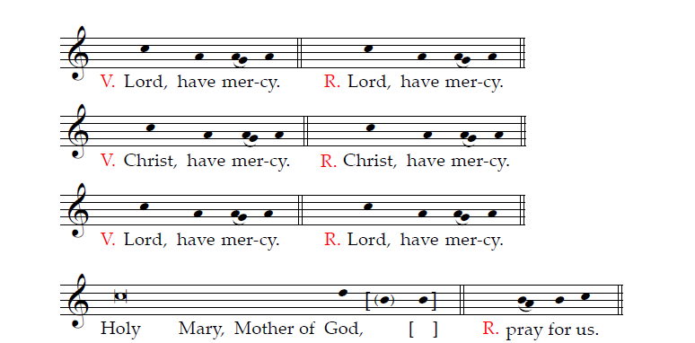

Saint Michael,
Holy Angels of God,
Saint John the Baptist,
Saint Joseph,
Saint Peter and Saint Paul,
Saint Andrew,
Saint John,
Saint Mary Magdalene,
Saint Stephen,
Saint Ignatius of Antioch,
Saint Lawrence,
Saint John de Brebeuf and the holy Canadian Martyrs,
Saint Perpetua and Saint Felicity,
Saint Agnes,
Saint Gregory,
Saint Augustine,
Saint Athanasius,
Saint Basil,
Saint Martin,
St. François de Laval,
Saint Pope John the Twenty-third,
Saint Pope John Paul the Second,
Saint Benedict,
Saint Francis and Saint Dominic,
Saint Francis Xavier,
Saint John Vianney,
Saint Brother Andre
Saint Catherine of Siena,
Saint Teresa of Jesus,
Saint Marie of the Incarnation,
Saint Marguerite Bourgeoys,
Saint Marguerite d’Youville,
Saint Kateri Tekakwitha,
All holy men and women, saints of God,

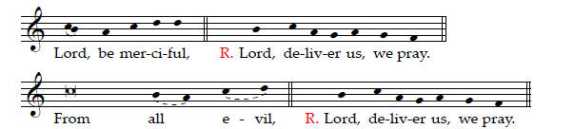

From every sin,
From everlasting death,
By your Incarnation,
By your Death and Resurrection,
By the outpouring of the Holy Spirit,

